Teachings of the DSH Peruvian Mystery School  Presented by:  Willaru Huayta, Peruvian Shaman | Magic from the Andes Mountains, Peru Conference  - April 1 – 2, 2017
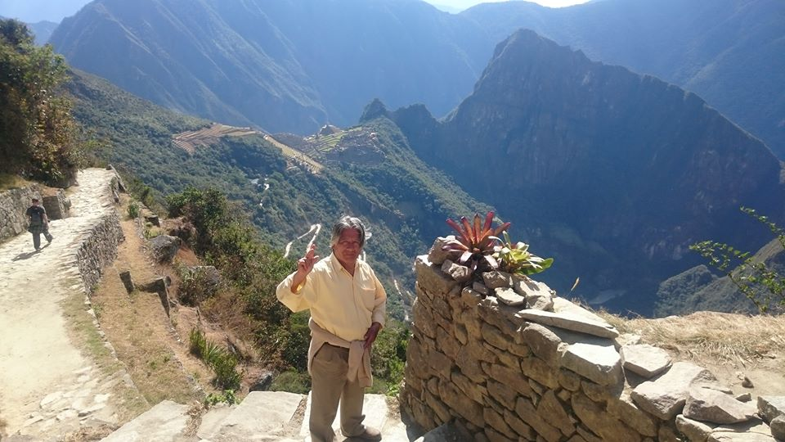  WILLARU HUAYTA is an Incan Spiritual Messenger from Cuzco, Peru. Born a Quetchua Indian in the Andes, he learned to receive truth during spiritual quests in the Amazon jungles from the masters of the inner cities and his interactions with local shamans. He had a vision to travel to Cuzco, as a Chasqui (messenger) for the Great White Brotherhood, with messages pertaining to the transitional times in which we live. When asked, Willaru states that he is not a teacher, a shaman, or any other form of hierarchical heritage.  “He simply says that he is a student of life.” | 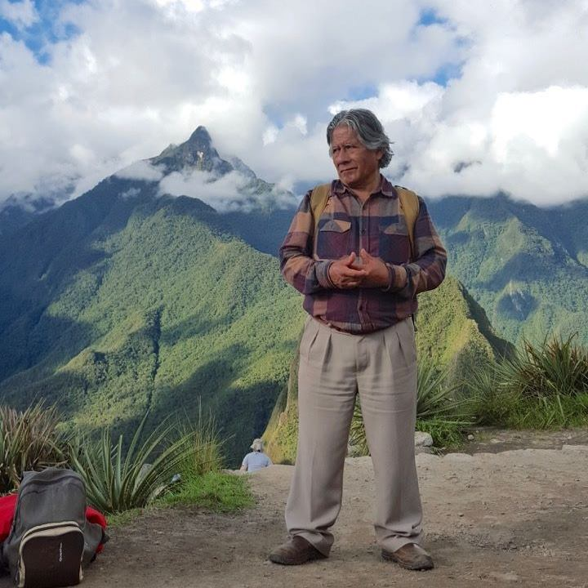  Conference Cost  Full 2 Day Conference………..……. $250  One Day of Conference………….... $125  Ind. (50min)Sessions ….…………. $100  Peru Cosmology Talk 1/31 PM $30  Main Office  Kuyuichi Kanchay Wasi  Conference Center  303 N. Grove, Standish, MI 48658
Conference topics:
Avatar for the Aquarian Age Law of Kharma and Darma How to Use Astral Projection
The Law of Evolution/Devolution/Revolution Law of the Sex for Human Kingdom
Cosmic, Intimate and Historical Christ The Ray of Death Elemental, Gnome and Other Beings
How to Negotiate the Jucha or Karma Hanan Pach, the Superior Dimension/Kingdom of God

Mediations:
Self-Remembering, Self-Observation, and Meditation on the Death of the Ego
Liberate YOUR Spiritual Essence, the transcendental initiation
for spiritual growth

